Chapter 5, Problem 11.

Using Fig. 5.50, design a problem to help other students better understand how ideal op amps work.

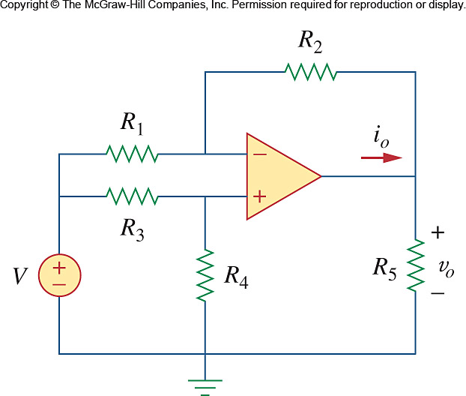

Figure 5.50
For Prob. 5.11.

